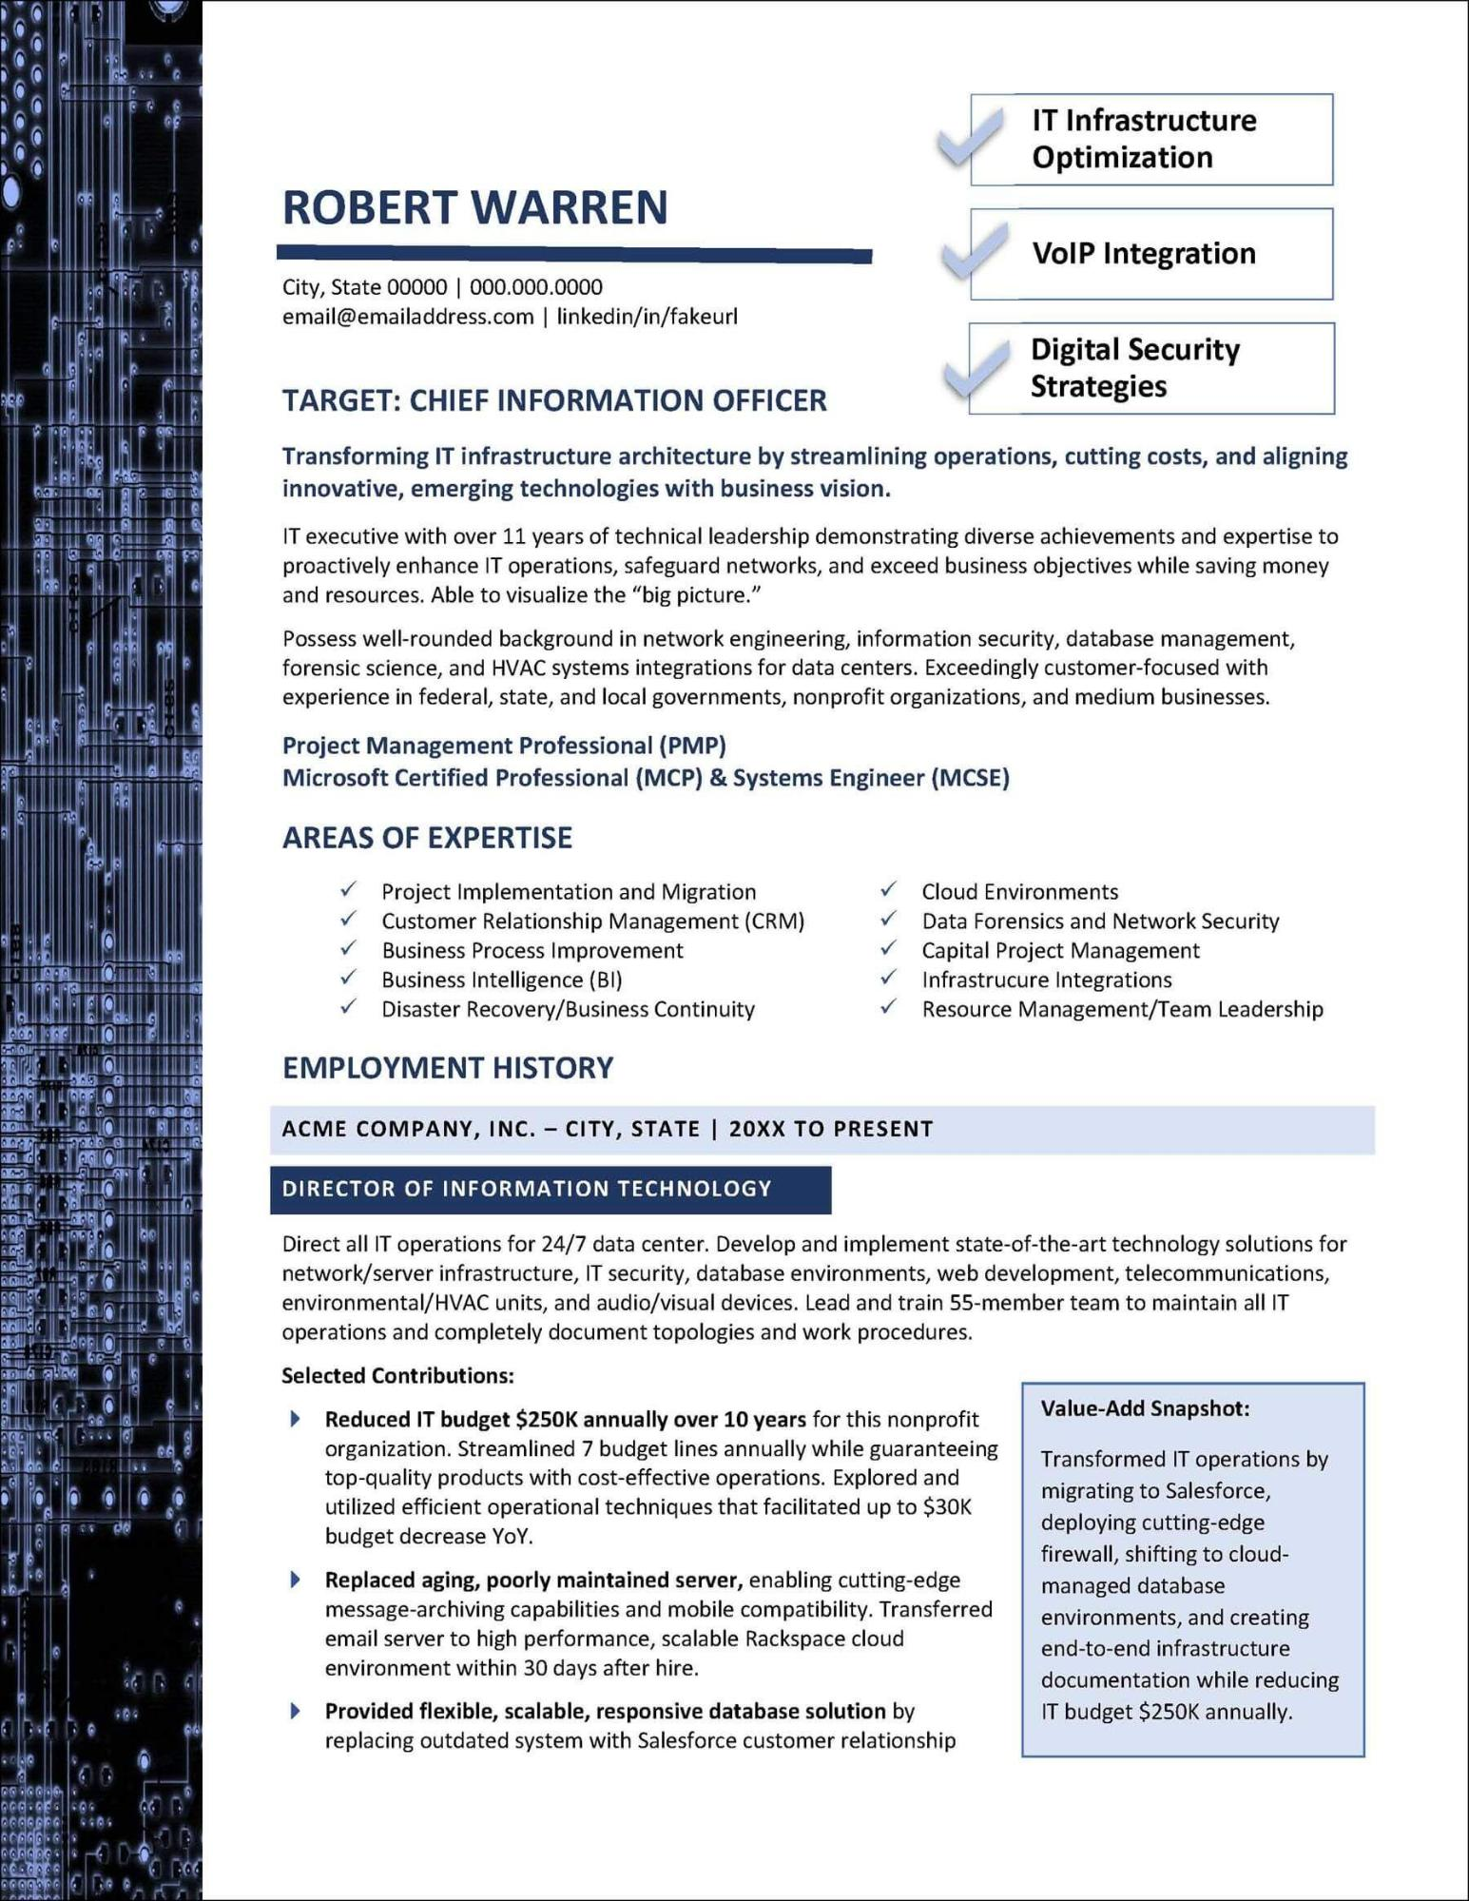
2000
000.000 .00 000000000
ROBERT WARREN
City, State 00000 | 000.000.0000
email@emailaddress.com | linkedin/in/fakeurl
IT Infrastructure
Optimization
VoIP Integration
Digital Security Strategies
TARGET: CHIEF INFORMATION OFFICER
Transforming IT infrastructure architecture by streamlining operations, cutting costs, and aligning innovative, emerging technologies with business vision.
IT executive with over 11 years of technical leadership demonstrating diverse achievements and expertise to proactively enhance IT operations, safeguard networks, and exceed business objectives while saving money and resources. Able to visualize the "big picture."
Possess well-rounded background in network engineering, information security, database management, forensic science, and HVAC systems integrations for data centers. Exceedingly customer-focused with experience in federal, state, and local governments, nonprofit organizations, and medium businesses. Project Management Professional (PMP)
Microsoft Certified Professional (MCP) & Systems Engineer (MCSE)
AREAS OF EXPERTISE
✓
Project Implementation and Migration
Customer Relationship Management (CRM) Business Process Improvement
Business Intelligence (BI)
Disaster Recovery/Business Continuity
EMPLOYMENT HISTORY
Cloud Environments
Data Forensics and Network Security Capital Project Management Infrastrucure Integrations
Resource Management/Team Leadership
ACME COMPANY, INC. - CITY, STATE | 20XX TO PRESENT
DIRECTOR OF INFORMATION TECHNOLOGY
Direct all IT operations for 24/7 data center. Develop and implement state-of-the-art technology solutions for network/server infrastructure, IT security, database environments, web development, telecommunications, environmental/HVAC units, and audio/visual devices. Lead and train 55-member team to maintain all IT operations and completely document topologies and work procedures.
Selected Contributions:
Reduced IT budget $250K annually over 10 years for this nonprofit organization. Streamlined 7 budget lines annually while guaranteeing top-quality products with cost-effective operations. Explored and utilized efficient operational techniques that facilitated up to $30K budget decrease YoY.
Replaced aging, poorly maintained server, enabling cutting-edge message-archiving capabilities and mobile compatibility. Transferred email server to high performance, scalable Rackspace cloud environment within 30 days after hire.
Provided flexible, scalable, responsive database solution by replacing outdated system with Salesforce customer relationship
Value-Add Snapshot:
Transformed IT operations by migrating to Salesforce, deploying cutting-edge firewall, shifting to cloud- managed database environments, and creating end-to-end infrastructure documentation while reducing IT budget $250K annually.

